Agri-business
Breakthrough
Webinar Series

Last Wednesday of each month at 12:00 GMT
Join the conversation…

Location
Online Event

Date
31 March 2021 (12:00 GMT)

Who should attend:
Impact investors; Development finance institutions; Commercial lenders; Agri-business companies and experts; Investment promotion agencies; Donors NGOs & Think Tanks.

Contact Information
Email: info@casaprogramme.com

JOIN HERE:
www.eventbrite.co.uk/e/monthly-casa-agri-business-breakthrough-webinars-tickets-123145596795
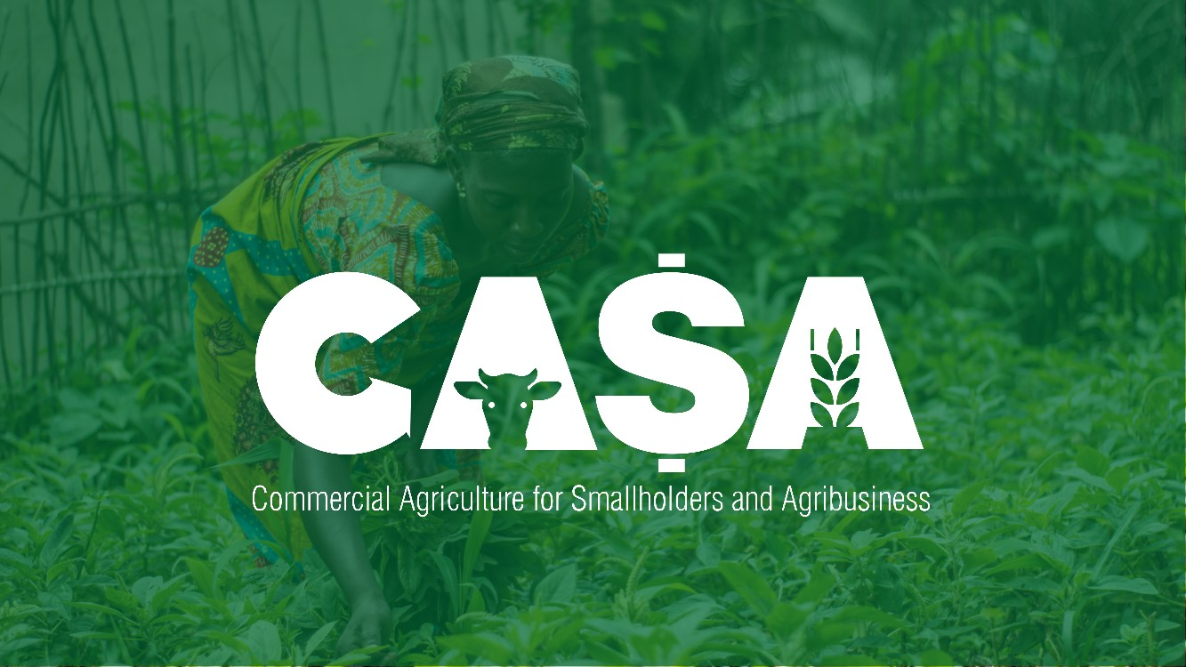

March 2021

Making Inclusivity Work
A role for legal empowerment

The March Breakthrough Webinar will explore the role legal empowerment can play in promoting smallholder farmers agency in commercial agriculture in developing countries.
Panellists from the Empowering Producers in Commercial Agriculture (EPIC) programme will share recommendations for capital providers based on their research and field experience. The background research is featured in three IIED publications exploring different aspects of working with farmer groups:
- Rural producer agency and agricultural value chains: What role for socio-legal empowerment?;
- Contracts in commercial agriculture: enhancing rural producer agency; and
- Socio-legal empowerment and agency of small-scale farmers in informal markets.
Agribusiness Breakthrough Webinars

Breakthrough webinars feature evidence and analysis by the CASA programme and partners, to support the commercialisation of agriculture in emerging markets across the developing world. The webinars are designed to showcase solutions to the most common challenges in agri-business for inclusive growth and support investment facilitation.

The Details

Each webinar will last 60-minutes and take place on the last Wednesday of the month until 2024. This webinar will be held on Wednesday 31 March at 12:00 GMT.

